Voice Control Robot using Arduino

Saini Vamshi

IOT/ROB - JUNE- BATCH 2

VOICE CONTROLLED ROBOT Using Arduino:

The purpose of this project is to implement the skills I gained during my internship period. A remote-controlled car allowed me to work with various sensors, actuators, software.

The working of remote-controlled robot goes like this:

We give the commands like *Forward, backward, left, and* right from the transmitter (in our case it is our mobile), Now these commands are received by the receiver that is Bluetooth module and the Arduino board will receive these signals from the TX and RX pins.

The Arduino board is responsible for guiding and controlling all the components that are used to make robot move.

To make Arduino board a responsible board we need to program the microcontroller.

Here we use the Arduino IDE platform to write, check, compile, and to upload the code to the Arduino.

REQUIRED COMPONENTS

* Arduino Uno R3
* HC-05 Bluetooth Module
* L293D Motor Driver
* 4 Wheeled Robot Chassis
* DC Motors X2
* Jumper wires
* 12-V Battery and Connectors

The connections:

Bluetooth connections:

* The Voltage pin is given to +5V
* The Ground is connected to the ground
* The Tx is Connected to Rx of Arduino
* The Rx is Connected to Tx of Arduino

L293D motor driver shield connections:

The L293D Motor Driver shield has all inbuilt connections. we need to check the matching of the driver pins and the Arduino pins and need to place the driver shield up on to the Arduino.

Now the 4 motors’, each having a +Ve and a -Ve terminal are inserted into their respective slots of motor driver

All these connections are made using jumper wires for ease access.

Motor Driver Circuit Diagram:

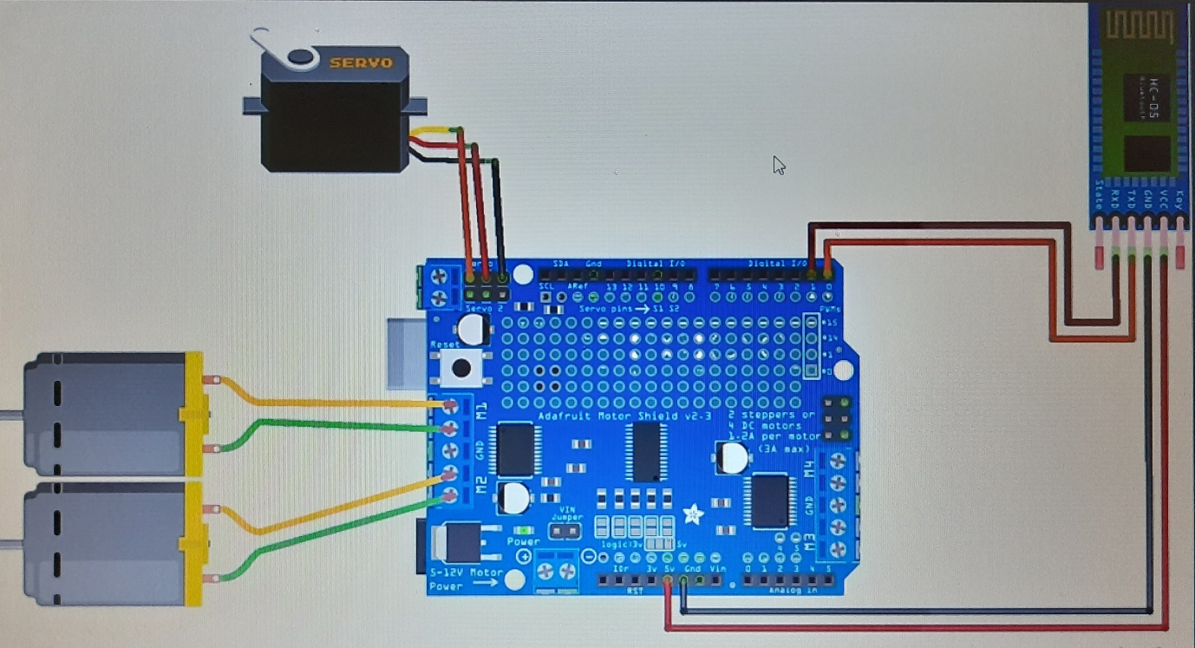

Note: (Servo motor is not used in the actual project).